Module 4
Module - 4

NATURE-BIOINSPIRED MATERIALS AND MECHANISMS:

Echolocation, Photosynthesis. Bird flying, Lotus leaf effect, Plant burrs, Shark skin, Kingfisher beak. Human Blood substitutes - hemoglobin-based oxygen carriers (HBOCs) and perflourocarbons (PFCs).

ECHOLOCATION:

In nature’s sonar system, echolocation occurs when an animal emits a sound wave that bounces off an object, returning an echo that provides information about the object’s distance and size. Over a thousand species echolocate, including most bats, all-toothed whales, and small mammals. Human echolocation is the ability of humans to detect objects in their environment by sensing echoes from those objects, and by actively creating sounds: for example, by tapping their canes, lightly stomping their feet, snapping their fingers, or making clicking noises with their mouths. People trained to orient by echolocation can interpret the sound waves reflected by nearby objects, accurately identifying their location and size.
Many blind individuals passively use natural environmental echoes to sense details about their environment; however, others actively produce mouth clicks and can gauge information about their environment using the echoes from those clicks. Both passive and active echolocation help blind individuals sense their environments.
Those who can see their environments often do not readily perceive echoes from nearby objects, due to an echo suppression phenomenon brought on by the precedence effect. However, with training, sighted individuals with normal hearing can learn to avoid obstacles using only sound, showing that echolocation is a general human ability.

Mechanics:
Vision and hearing are akin in that each interprets detections of reflected waves of energy. Vision processes light waves that travel from their source, bounce off surfaces throughout the environment and enter the eyes. Similarly, the auditory system processes sound waves as they travel from their source, bounce off surfaces, and enter the ears. Both neural systems can extract a great deal of information about the environment by interpreting the complex patterns of reflected energy that their sense organs receive. In the case of sound, these waves of reflected energy are

referred to as echoes.

ULTRASONOGRAPHY:

Ultrasound:
Ultrasound refers to sound above the human audible limit of 20 kHz. Ultrasound of frequencies up to 10 MHz and beyond is used in medical diagnosis, therapy, and surgery. In investigative applications, an ultrasound source (transmitter) directs pulses into the body.
When the pulse encounters a boundary between organs or between two tissue regions of different densities, reflections of sound occur. By scanning the body with Ultrasound and detecting echoes generated by various organs, a sonogram of the internal structure(s) can be generated. The method is called diagnostic imaging by echolocation.

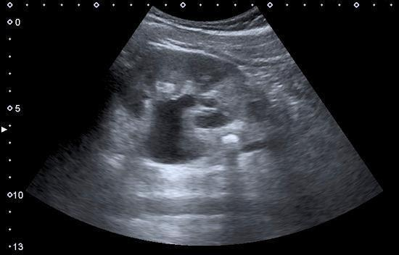

COURTESY: ALANA BIGGERS
SONOGRAPHY OF KIDNEY

Diagnostic ultrasound, also called sonography or diagnostic medical sonography, is an imaging method that uses sound waves to produce images of structures within your body. The images can provide valuable information for diagnosing and directing treatment for a variety of diseases and conditions.

SONARS:
Sonar (sound navigation and ranging or sonic navigation and ranging) is a technique that uses

sound propagation (usually underwater, as in submarine navigation) to navigate, measure distances (ranging), communicate with or detect objects on or under the surface of the water, such as other vessels.
"Sonar" can refer to one of two types of technology:
- passive sonar means listening for the sound made by vessels;
- active sonar means emitting pulses of sounds and listening for echoes.
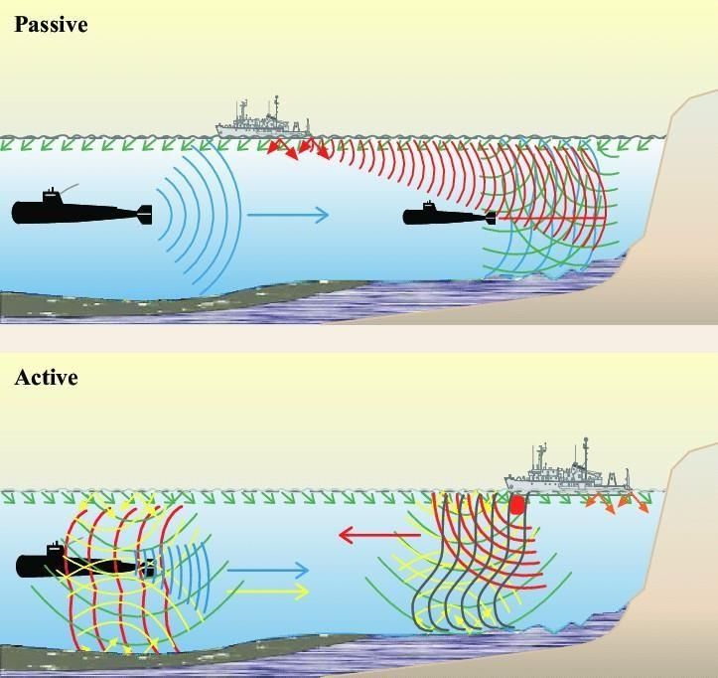
COURTESY: PHILIPPE ROUX

Sonar may be used as a means of acoustic location and of measurement of the echo characteristics of "targets" in the water. Acoustic location in the air was used before the introduction of radar. Sonar may also be used for robot navigation, and SODAR (an upward-looking in-air sonar) is used for atmospheric investigations. The term sonar is also used for the equipment used to generate and receive the sound. The acoustic frequencies used in sonar systems vary from very low (infrasonic) to extremely high (ultrasonic). The study of underwater sound is known as underwater acoustics or hydroacoustics.

PHOTOSYNTHESIS:

Most life on Earth depends on photosynthesis. The process is carried out by plants, algae, and some types of bacteria, which capture energy from sunlight to produce oxygen (O2) and chemical energy stored in glucose (a sugar). Herbivores then obtain this energy by eating plants, and carnivores obtain it by eating herbivores.
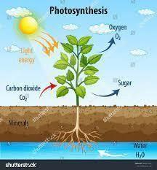

The Process:
During photosynthesis, plants take in carbon dioxide (CO2) and water (H2O) from the air and soil. Within the plant cell, the water is oxidized, meaning it loses electrons, while the carbon dioxide is reduced, meaning it gains electrons. This transforms the water into oxygen and the carbon dioxide into glucose. The plant then releases the oxygen back into the air, and stores energy within the glucose molecules.

Chlorophyll:
Inside the plant cell are small organelles called chloroplasts, which store the energy of sunlight. Within the thylakoid membranes of the chloroplast is a light-absorbing pigment called chlorophyll, which is responsible for giving the plant its green color. During photosynthesis, chlorophyll absorbs energy from blue- and red-light waves and reflects green-light waves, making the plant appear green.

PHOTOVOLTAIC CELLS:

WHAT IS PHOTOVOLTAIC?
The sun’s copious energy is captured by two engineering systems: photosynthetic plant cells and photovoltaic cells (PV). Photosynthesis converts solar energy into chemical energy, delivering different types of products such as building blocks, biofuels, and biomass; photovoltaics turn it into electricity which can be stored and used to perform work.

Understanding better the way by which natural photosynthetic complexes perform these processes may lead to insight into the design of artificial photosynthetic systems and the development of new

technologies for solar energy conversion. A broad variety of bio-inspired concepts and applications are emerging, ranging from light-induced water splitting, Plant Microbial Fuel Cells to hybrid systems. These latter combine photosynthesis and photovoltaics and have great potential in agriphotovoltaic concepts such as the side-by-side arrangement of solar cells and plants, and systems consisting of transparent solar cells which are placed in front or above the plant. One of the applications that can contribute to bringing together the worlds of photosynthesis and photovoltaics is the photovoltaic cell.
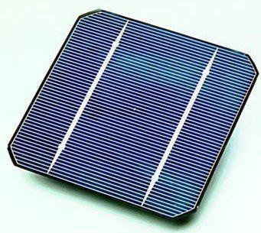
solar cell

A solar cell, or photovoltaic cell, is an electronic device that converts the energy of light directly into electricity by the photovoltaic effect, which is a physical and chemical phenomenon. It is a form of photoelectric cell, defined as a device whose electrical characteristics, such as current, voltage, or resistance, vary when exposed to light. Individual solar cell devices are often the electrical building blocks of photovoltaic modules, known colloquially as solar panels. The common single-junction silicon solar cell can produce a maximum open-circuit voltage of approximately 0.5 volts to 0.6 volts.

Application:
- Remote Locations
- Stand-Alone Power.
- Power in Space.
- Building-Related Needs.
- Military Uses.
- Transportation.

BIONIC LEAF:

The Bionic Leaf is a biomimetic system that gathers solar energy via photovoltaic cells that can

be stored or used in several different functions. Bionic leaves can be composed of both synthetic (metals, ceramics, polymers, etc.) and organic materials (bacteria), or solely made of synthetic materials. The Bionic Leaf has the potential to be implemented in communities, such as urbanized areas to provide clean air as well as providing needed clean energy.
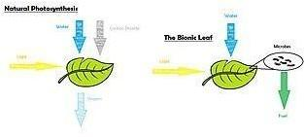
COURTESY: NOCERA, DANIEL G

Mechanics:
Natural Photosynthesis vs. The Bionic Leaf at its simplest form.
In natural photosynthesis, photosynthetic organisms produce energy-rich organic molecules from water and carbon dioxide by using solar radiation. Therefore, the process of photosynthesis removes carbon dioxide, a greenhouse gas, from the air. Artificial photosynthesis, as performed by the Bionic Leaf, is approximately 10 times more efficient than natural photosynthesis. Using a catalyst, the Bionic Leaf can remove excess carbon dioxide in the air and convert that to use alcohol fuels, like isopropanol and isobutanol.
The efficiency of the Bionic Leaf's artificial photosynthesis is the result of bypassing obstacles in natural photosynthesis through its artificiality. In natural systems, numerous energy conversion bottlenecks limit the overall efficiency of photosynthesis. As a result, most plants do not exceed 1% efficiency and even microalgae grown in bioreactors do not exceed 3%. Existing artificial photosynthetic solar-to-fuels cycles may exceed natural efficiencies but cannot complete the cycle via carbon fixation. When the catalysts of the Bionic Leaf are coupled with the bacterium Ralstonia eutropha, this results in a hybrid system capable of carbon dioxide fixation. This system can store more than half of its input energy as products of carbon dioxide fixation. Overall, the hybrid design allows for artificial photosynthesis with efficiencies rivaling that of natural photosynthesis.

Applications:
- Agriculture
- Atmosphere
- Bionic Facades

BIRD FLYING:

Bird flight is the primary mode of locomotion used by most bird species in which birds take off and fly. Flight assists birds with feeding, breeding, avoiding predators, and migrating.
Bird flight is one of the most complex forms of locomotion in the animal kingdom. Each facet of this type of motion, including hovering, taking off, and landing, involves many complex

movements. As different bird species adapted over millions of years through evolution for specific environments, prey, predators, and other needs, they developed specializations in their wings and acquired different forms of flight.

GPS:

GPS is a system. It’s made up of three parts: satellites, ground stations, and receivers. Satellites act like stars in constellations—we know where they are supposed to be at any given time. The ground stations use radar to make sure they are actually where we think they are. A receiver, as you might find in your phone or your car, is constantly listening for a signal from these satellites. The receiver figures out how far away they are from some of them.
Once the receiver calculates its distance from four or more satellites, it knows exactly where you are. Presto! From miles up in space your location on the ground can be determined with incredible precision! They can usually determine where you are within a few yards of your actual location. More high-tech receivers, though, can figure out where you are within a few inches!

GPS AND BIRD FLIGHT:

Scientists have long known that birds navigate using the earth’s magnetic field. Now, a new study has found subtle mechanics in the brain of pigeons that allow them to find their way.
A team at Baylor College of Medicine in the U.S. identified a group of 53 cells in a pigeon’s brain that record detailed information on the Earth’s magnetic field, a kind of internal global positioning system (GPS).

Experiment:
Prof. Dickman and his colleague Le-Qing Wu set up an experiment in which pigeons were held in a dark room and used a 3D coil system to cancel out the planet’s natural geomagnetic field and generate a tunable, artificial magnetic field inside the room. While they adjusted the elevation angles and magnitude of their artificial magnetic field, they simultaneously recorded the activity of the 53 neurons in the pigeons’ brains which had already been identified as candidates for such sensors.
So, they measured the electrical signals from each one as the field was changed and found that every neuron had its characteristic response to the magnetic field, each giving a sort of 3-D compass reading along the familiar north-south directions as well as pointing directly upward or downward. In life, this could help the bird determine not only it's heading just as a compass does, but would also reveal its approximate position, the researchers said.
Each cell also showed a sensitivity to field strength, with the maximum sensitivity corresponding to the strength of the Earth’s natural field, they added. And like a compass, the neurons had opposite responses to different field “polarity”, the magnetic north and south of a field, which surprised the researchers most of all. Several hypotheses hold that birds’ magnetic navigation arises in cells that contain tiny chunks of metal in their noses or beaks, or possibly in an inner ear organ.
However, the most widely held among them was thrown into question when researchers found that purported compass cells in pigeon beaks were a type of white blood cell.

AIRCRAFT:

MECHANISM:

Lift, Drag, and Thrust:
The fundamentals of bird flight are similar to those of aircraft, in which the aerodynamic forces sustain flight lift, drag, and thrust. Lift force is produced by the action of airflow on the wing, which is an airfoil. The airfoil is shaped such that the air provides a net upward force on the wing, while the movement of air is directed downward. The additional net lift may come from airflow around the bird's body in some species, especially during intermittent flight while the wings are folded or semi-folded (cf. lifting body).
Aerodynamic drag is the force opposite to the direction of motion, and hence the source of energy loss in flight. The drag force can be separated into two portions, lift-induced drag, which is the inherent cost of the wing producing lift (this energy ends up primarily in the wingtip vortices), and parasitic drag, including skin friction drag from the friction of air and body surfaces and form drag from the bird's frontal area. The streamlining of the bird's body and wings reduces these forces. Unlike aircraft, which have engines to produce thrust, birds flap their wings with a given flapping amplitude and frequency to generate thrust.

LOTUS LEAF EFFECT:
The lotus leaf is well-known for having a highly water-repellent, or superhydrophobic, surface, thus giving the name to the lotus effect. Water repellency has received much attention in the development of self-cleaning materials, and it has been studied in both natural and artificial systems.

SUPERHYDROPHOBIC AND SELF-CLEANING SURFACES:

The self-cleaning function of superhydrophobic surfaces is conventionally attributed to theremoval of contaminating particles by impacting or rolling water droplets, which implies the action of external forces such as gravity. Here, we demonstrate a unique self-cleaning mechanism whereby the contaminated superhydrophobic surface is exposed to condensing water vapor, and the contaminants are autonomously removed by the self-propelled jumping motion of the resulting liquid condensate, which partially covers or fully encloses the contaminating particles. The jumping motion of the superhydrophobic surface is powered by the surface energy released upon the coalescence of the condensed water phase around the contaminants. The jumping-condensate mechanism is shown to spontaneously clean superhydrophobic cicada wings, where the contaminating particles cannot be removed by gravity, wing vibration, or wind flow. Our findings offer insights into the development of self-cleaning materials.

Mechanism:
An autonomous mechanism to achieve self-cleaning on superhydrophobic surfaces, where the contaminants are removed by self-propelled jumping condensate powered by surface energy. When exposed to condensing water vapor, the contaminating particles are either fully enclosed or partially covered with the resulting liquid condensate. Building upon our previous publications
showing self-propelled jumping upon drop coalescence (5, 6), we show particle removal by the
merged condensate drop with a size comparable to or larger than that of the contaminating particle(s). Further, we report a distinct jumping mechanism upon particle aggregation, without a condensate drop of comparable size to that of the particles, where a group of particles exposed to water condensate clusters together by capillarity and self-propels away from the superhydrophobic surface.

PLANT BURRS:

A bur (also spelled burr) is a seed or dry fruit or infructescence that has hooks or teeth. The main function of the bur is to spread the seeds of the bur plant, often through epizoochory. The hooks of the bur are used to catch on to for example fur or fabric, so that the bur, which contains seeds, then can be transported along with the thing it attached itself to. Another use for the spines and hooks is physical protection against herbivores. Their ability to stick to animals and fabrics has shaped their reputation as bothersome.
Some other forms of diaspores, such as the stems of certain species of cactus also are covered with thorns and may function as burs. Bur-bearing plants such as Xanthium species are often single- stemmed when growing in dense groups, but branch and spread when growing singly. The number of burs per fruit along with the size and shape can vary largely between different bur plants.
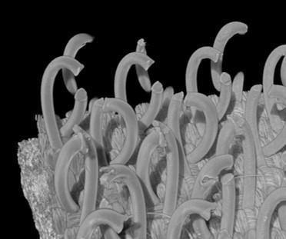

MICROSCOPIC VIEW OF BURR
COURTESY: ŠUKLJE, TOMAZ

Relevance to humans:
Burs are best known as sources of irritation, injury to livestock, damage to clothing, punctures to tires, and clogging equipment such as agricultural harvesting machinery. Furthermore, because of their ability to compete with crops over moisture and nutrition, bur plants can be labeled as weeds and therefore also be subject to removal. Methods of controlling the spread of bur plants include the use of herbicides, slashing, and cultivation among others.
Some have however been used for such purposes as fabric fulling, for which the fuller's teasel is a traditional resource. The bur of burdock was the inspiration for the hook and loop fastener, also known as Velcro.

VELCRO:

Mr. de Mestral examined the burr under a microscope and realized the small hooks of the burr and loops of the fur/fabric allowed the burr to adhere exceedingly well. This sparked his idea to mimic the structure as a potential fastener.
Originally VELCRO is envisioned as a fastener for clothing, today, Velcro is used across a wide array of industries and applications; including healthcare, the military, land vehicles, aircraft, and even spacecraft.
SHARK SKIN:

The texture is rough since it has small scales similar to teeth, called Dermal Denticles. Each species has a uniquely shaped denticle. They have a covering of dentine, a central pulp canal containing blood vessels, and a single nerve.
The denticles play an important part in swimming efficiency. The water is channeled by the ‘skin teeth' and flows across the fins and around the body. The teeth also break up the interface between skin and water, reducing the friction between the two entities. The teeth and skin also help protect the shark from injuries and several elements in the water. It's like a suit of armor for sharks.

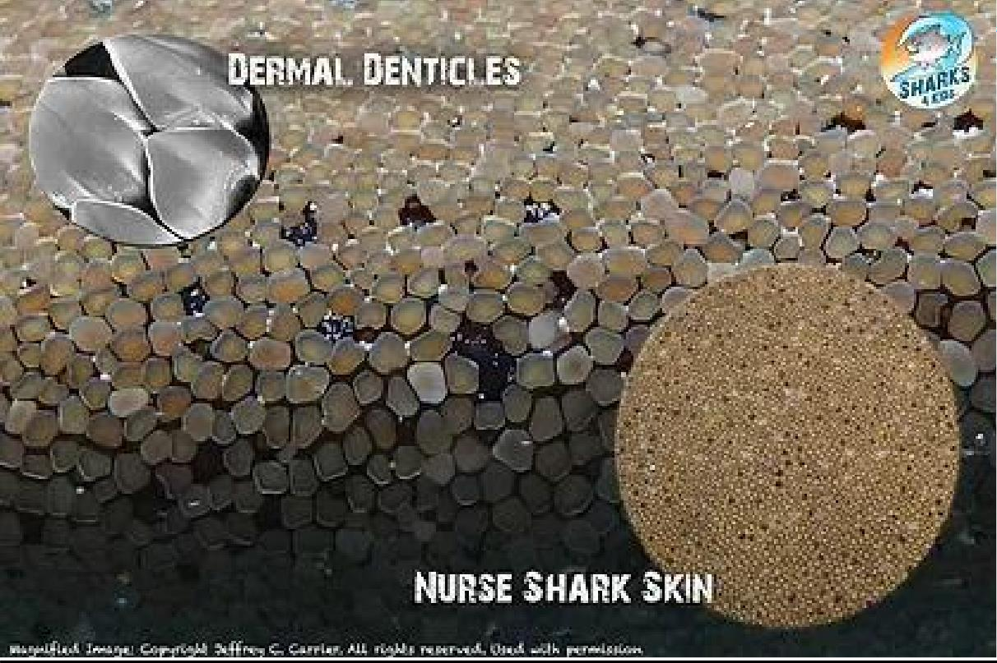
COURTESY: CROSS, DANIEL T

Relevance to humans:
It is typically made with acetate and rayon yarns, as well as with worsted wool and various synthetic blends. The combination of the color of the yarns and the twill weaving pattern in which the colored threads run diagonally to the white yarns results in the finish for which sharkskin fabric is known. It has a smooth but crisp texture and a two-tone lustrous appearance. Lightweight and wrinkle-free, sharkskin is ideal for curtains, tablecloths, and napkins. Sharkskin fabric is popular for both men’s and women’s worsted suits, light winter jackets, and coats. Sharkskin is commonly used as a liner in diving suits and wetsuits.

SHARK SKIN AND SWIMSUITS:

Scientists have been able to replicate the dermal denticles in swimsuits and also the bottom of ships or boats. When cargo ships can squeeze out even a single percent in efficiency, they burn less bunker oil and don’t require cleaning chemicals for their hulls. Besides that, this sharkskin mechanism is also applied to create surfaces in hospitals that resist bacteria growth since the bacteria can’t catch hold of the rough surface.
Sharkskin-inspired swimsuits received a lot of media attention during the 2008 Summer Olympics when the spotlight was shining on Michael Phelps. However, they are now banned in most of the
major competitions.

KINGFISHER BEAK:

The kingfishers have long, dagger-like bills. The bill is usually longer and more compressed in species that hunt fish, and shorter and broader in species.

Relationship with humans:
Kingfishers are generally shy birds, but despite this, they feature heavily in human culture, generally due to the large head supporting its powerful mouth, their bright plumage, or some species' interesting behavior.
For the Dusun people of Borneo, the Oriental dwarf kingfisher is considered a bad omen, and warriors who see one on the way to battle should return home. Another Bornean tribe considers the banded kingfisher an omen bird, albeit generally a good omen. The sacred kingfisher, along with other Pacific kingfishers, was venerated by the Polynesians, who believed it had control over the seas and waves.

THE BEAK THAT INSPIRED A BULLET TRAIN:

The Strategy:
The secret is in the shape of the kingfisher’s beak. A long and narrow cone, the kingfisher’s beak parts and enters the water without creating a compression wave below the surface or a noisy splash above. The fine point of the conical beak presents little surface area or resistance to the water upon entry, and the evenly and gradually enlarging cross-section of the beak keeps fluid flowing smoothly around it as it penetrates further into the water column. This buys the bird crucial milliseconds to reach the fish before the fish knows to flee. The length of the beak is critical here: the longer it is, the more gradually the angle of the wedge expands. A shorter, fatter, or rounder beak would increase the wedge angle, resulting in a splash, a compression wave, and a fleeing fish.

The Potential:
Eiji Nakatsu, the chief engineer of the company operating Japan’s fastest trains, wondered if the kingfisher’s beak might serve as a model for how to redesign trains not to create such a thunderous noise when leaving tunnels and breaking through the barrier of tunnel air and outside-air. Sure enough, as his team tested different shapes for the front of the new train, the train became quieter and more efficient as the geometry of its nose became more like the shape of a kingfisher’s beak, requiring 15% less energy while traveling even faster than before.

HUMAN BLOOD SUBSTITUTES:

Shortages in blood supplies and concerns about the safety of donated blood have fueled the development of so-called blood substitutes. The two major types of blood substitutes are volume expanders, which include solutions such as saline that are used to replace lost plasma volume, and oxygen therapeutics, which are agents designed to replace oxygen normally carried by the hemoglobin in red blood cells. Of these two types of blood substitutes, the development of oxygen
therapeutics has been the most challenging. One of the first groups of agents developed and teste
were perfluorocarbons, which effectively transport and deliver oxygen to tissues but causecomplex side effects, including flulike reactions, and are not metabolized by the body.
Other oxygen therapeutics include agents called hemoglobin-based oxygen carriers (HBOCs), which are made by genetically or chemically engineering hemoglobin isolated from the red blood cells of humans or bovines. HBOCs do not require refrigeration, are compatible with all blood types, and efficiently distribute oxygen to tissues. A primary concern associated with these agents is their potential to cause severe immune reactions.
Blood from the human umbilical cord has been studied for its potential as a substitute source of red blood cells for transfusion. Red blood cells can be extracted from cord blood via sedimentation as the blood is cooled. Donated cord blood can be screened for infectious organisms and other contaminants. Research concerning its potential use for transfusion is ongoing. Of particular concern for implementation are the establishment of safe, effective, and ethical procedures for cord blood collection as well as the development of criteria that help to ensure safe transfusion and the preservation of cord blood quality.

Hemoglobin-based oxygen carriers (HBOCs) AND Perfluorocarbons (PFC) : Pharmaceutical companies attempted to develop HBOCs (also called oxygen therapeutics) and PFCs starting in the 1980s and at first, seemed to have some success. However, the results of most human clinical trials have been disappointing. A study published in 2008 in the Journal of the American Medical Association summarized the results of 16 clinical trials on five different blood substitutes administered to 3,500 patients.
Those receiving blood substitutes had a threefold increase in the risk of heart attacks compared with the control group given human donor blood. However, a closer analysis of the results showed that some of the negative statistics were misleading.
The artificial blood products reviewed in this study varied in their benefits and risks, and some blood substitutes had very few serious side effects. The findings suggest that some blood substitutes may be safer and more beneficial than scientists originally thought.

- HBOCs:
Hemoglobin-based oxygen carriers (HBOCs) are “made of” natural hemoglobins that were originally developed as blood substitutes but have been extended to a variety of hypoxic clinical situations due to their ability to release oxygen. Compared with traditional preservation protocols, the addition of HBOCs to traditional preservation protocols provides more oxygen to organs to meet their energy metabolic needs, prolongs preservation time, reduces ischemia-reperfusion injury to grafts, improves graft quality, and even increases the number of transplantable donors. The focus of the present study was to review the potential applications of HBOCs in solid organ preservation and provide new approaches to understanding the mechanism of promising strategies for organ preservation.

- PFCs:
PFCs remain in the bloodstream for about 48 hours. Because of their oxygen-dissolving ability, PFCs were the first group of artificial blood products studied by scientists. They are first- generation blood substitutes. Unlike the red-colored HBOCs, PFCs are usually white. However, since they do not mix with blood they must be emulsified before they can be given to patients. PFCs are such good oxygen carriers that researchers are now trying to find out if they can reduce

swollen brain tissue in traumatic brain injury. PFC particles may cause flu-like symptoms in some patients when they exhale these compounds.

